October 8, 2020
Ref: IIH/MD/2020/10/005
His Excellency,
The Executive Governor of Kwara State,
Government House,
Ahmadu Bello Way,
GRA, Ilorin, Kwara State.
Dear Sir,
REQUEST FOR APPROVAL TO CHANGE OF DIRECTORS ON ILORIN INNOVATION HUB
COMPANY REGISTRATION
Following His Excellency’s instruction to change the ownership of the Ilorin Innovation Hub Limited (registered with RC number 1664691 with the Corporate Affairs Commission in Abuja, Nigeria) to be fully owned by the Kwara State Government, I would like to formally request that the company ownership be changed to have the following directors:
SN | Name of Director  (representing the Kwara State Government) | Position | % of share allocation
1 | Hon. Olasumbo Florence Oyeyemi | Commissioner for Finance and Planning | 70%
2 | Temi Kolawole | MD Ilorin Innovation Hub | 30%

These directors will replace all previous directors including the majority shareholder, Harmony Holdings Ltd.
Thank you.
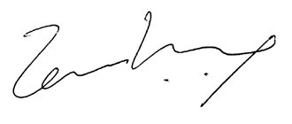

Temi Kolawole
MD Ilorin Innovation Hub

